ENGE707: Data Engineering and Machine Learning Pipeline Project
Phase 1: Mid-Project Scoping Report
How Does AI Adoption Rate Compare with Productivity Rate? A Data Engineering and Exploratory Analysis of Company-Level AI Adoption
Prepared by: [Group member names]
Student ID(s): [XXXXXXXX]
Course: ENGE707 — Data Engineering and Artificial Intelligence
Lecturer: [Lecturer name]
Institution: Auckland University of Technology
Date: 25 August 2026
Word count: approximately 3,000 words (excluding table of contents, tables, figures, and references)

Table of Contents

(Right-click the table above and select “Update Field” in Microsoft Word to populate page numbers.)

1. Introduction
Real-world businesses increasingly invest in artificial intelligence to improve operational performance, yet the relationship between the scale of that investment and the resulting productivity gain is not always straightforward (OECD, 2024). Organisations across every sector are under pressure to justify AI spending with measurable outcomes, which places data-driven evaluation of AI adoption at the centre of contemporary technology strategy (OECD/BCG/INSEAD, 2025). This report addresses a single, focused research question: how does a company’s rate of AI adoption compare with the productivity change it subsequently reports. The question directly serves company executives, technology investment committees, and policymakers who must decide whether continued AI investment is producing a measurable return.
An earlier draft of this project examined several AI-related variables at once, including maturity, ethics governance, and workforce displacement. Following feedback from the course lecturer, the analysis was narrowed to this single comparison so that each stage of the pipeline could be examined in sufficient depth. This report documents the four required tasks of the Phase 1 scoping report: problem and dataset selection, data acquisition and inspection, data cleansing and transformation, and exploratory data analysis.

2. Problem Definition and Dataset Selection

2.1 Motivation and Stakeholders
Executives responsible for AI budgets need evidence of whether adoption converts into productivity gains before approving further investment. Government agencies that shape technology policy, such as the OECD, are similarly interested in whether AI adoption is delivering the productivity growth that has been forecast for national economies (OECD, 2024). Workforce planners and human-resource teams need to understand whether higher AI adoption is associated with broader operational change, since this shapes retraining and staffing decisions. The dataset selected for this project is well suited to informing each of these groups because it links a direct, company-level measure of AI adoption to a directly reported productivity outcome.

2.2 Dataset Description and Justification
The dataset used in this project is the Global AI Adoption and Workforce Impact Dataset, obtained from the Kaggle data-sharing platform (Thalla, 2026). It is distributed under Kaggle’s standard dataset terms of use; a specific open licence was not stated on the dataset landing page at the time of access, so the access date and terms are documented here for reproducibility rather than assumed. The dataset contains 150,000 company-quarter survey responses, drawn from 10,000 distinct companies across 30 countries and 9 industries, surveyed quarterly from the first quarter of 2023 to the fourth quarter of 2026.
Each response contains 43 columns, comfortably satisfying the Phase 1 requirement of more than 20 and fewer than 300 features. The dataset is tabular and alphanumeric throughout, meeting the assignment’s dataset-format requirement, and it is documented with descriptive column names that allow each variable’s meaning to be established without external metadata. Two columns form the focus of this project: ai_adoption_rate, which records the percentage of a company’s operations or processes that use AI, and productivity_change_percent, which records the percentage change in productivity the company subsequently reported. The dataset therefore provides a direct, company-level pairing of an AI-adoption measure and a productivity outcome, which is precisely the relationship this project has been narrowed to examine.

3. Data Engineering Pipeline Overview
The data engineering pipeline implemented for this project follows the extract-transform-load structure introduced in the ENGE707 Week 2 and 3 lecture material (Auckland University of Technology [AUT], 2026b). Figure 1 summarises the five stages applied to the dataset: extraction from the Kaggle CSV file, inspection of structure and quality, cleaning and transformation, loading into a small SQLite database, and exploratory analysis.
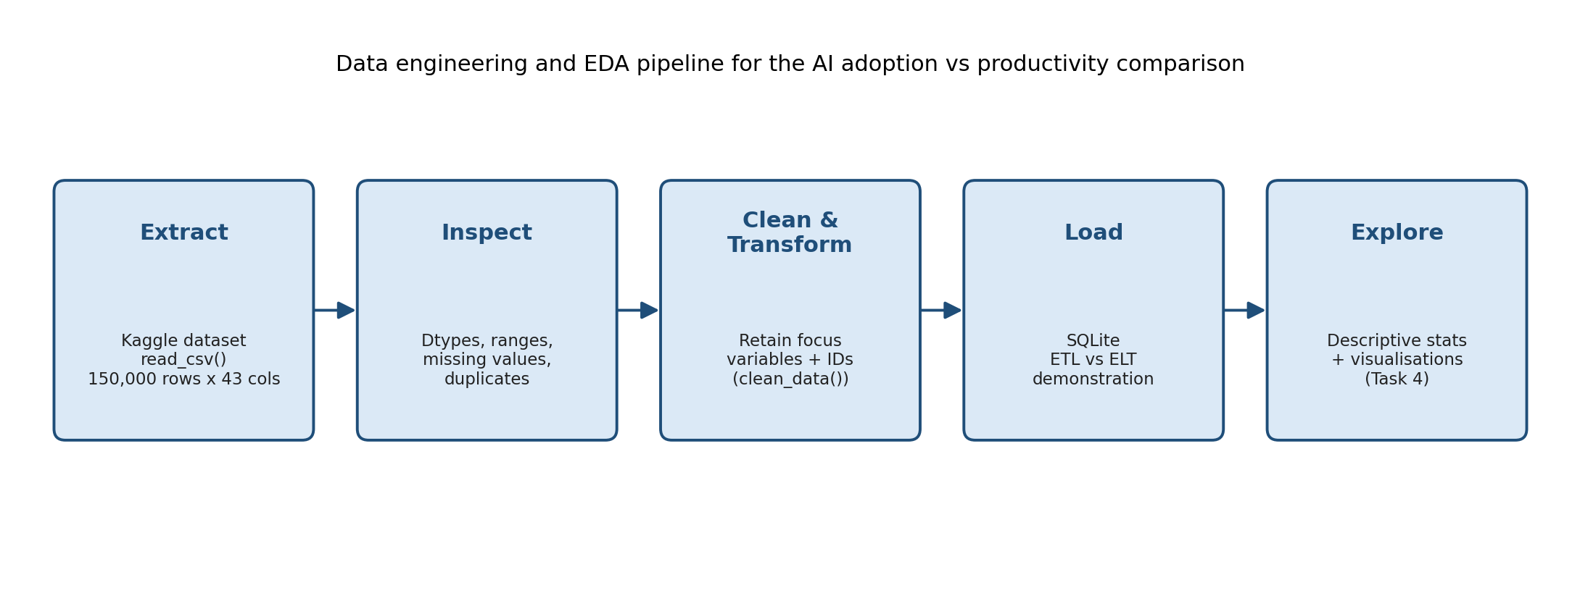
Figure 1. The five-stage data engineering pipeline applied to the AI adoption and productivity comparison.
Both the ETL and ELT patterns taught in the course were demonstrated using this dataset, storing the cleaned two-variable table directly in one database and storing the untouched raw table in a second database before transforming it on read (AUT, 2026b). Learning both patterns within the same pipeline made the practical trade-off between them concrete for this project. The ETL database stored only the final, narrow table needed for this comparison, while the ELT database retained the full 43-column raw table so that a different comparison could be produced later without re-extracting the source file. This trade-off matters for a project that has just been asked to narrow its scope, because an ELT-style raw copy means the original 43 columns remain available if a later phase requires additional variables.

4. Data Acquisition, Inspection and Documentation

4.1 Loading and Structural Inspection
The dataset was loaded into Python using pandas.read_csv(), following the loading procedure demonstrated in the Week 2 and 3 lecture material for the course’s own arrhythmia dataset (AUT, 2026b). Loading produced a DataFrame of 150,000 rows and 43 columns, matching the file’s published dimensions. Table 1 summarises the structural properties of the dataset confirmed during this inspection stage.
Table 1. Structural summary of the Global AI Adoption and Workforce Impact Dataset.
Property | Value
Total records (rows) | 150,000
Total columns | 43
Distinct companies | 10,000
Countries represented | 30
Industries represented | 9
Company size categories | 3 (Startup, SME, Enterprise)
Survey period | Q1 2023 – Q4 2026 (16 quarters)
Focus variables | ai_adoption_rate, productivity_change_percent
An initial inspection of column data types confirmed that the dataset contains 15 float columns, 14 integer columns, 13 string columns, and one column, quarter, that was explicitly converted to a categorical type because it takes only four repeating values. This inspection step reflects the course’s emphasis on checking a dataset’s structure and data types before any cleaning decision is made, so that cleaning rules are built on an accurate understanding of what each column contains (AUT, 2026a).
The categorical columns of the dataset were also inspected for their unique values, consistent with the course’s instruction to check unique values alongside data types (AUT, 2026a). The dataset spans 30 countries and 9 industries, including education, finance, manufacturing, healthcare, and retail, and it classifies each company into one of three size categories: startup, small-to-medium enterprise, or enterprise. Four data-collection methods are recorded, comprising API scrape, phone interview, research compilation, and online survey, alongside four named survey sources. This categorical variety is noted here because it is not used directly in the narrowed two-variable comparison, but it confirms that the dataset covers a broad and varied population of companies rather than a narrow or unrepresentative sample, which supports the practical relevance argued for in Section 2.

4.2 Data-Quality Inspection of the Focus Variables
Following the course’s data-quality checklist of missing values, duplicate records, and implausible ranges (AUT, 2026a), both focus variables were inspected before any cleaning was applied. Neither ai_adoption_rate nor productivity_change_percent contained a missing value across all 150,000 records, which was confirmed and printed explicitly rather than assumed. No fully duplicate rows and no duplicated response_id values were present in the raw dataset.
The recorded range of ai_adoption_rate was 0% to 100%, matching its definition as a percentage, and the recorded range of productivity_change_percent was 0% to 34.36%, with no negative values present. These ranges are internally consistent with each variable’s documented meaning, so no implausible or out-of-range values needed correction at this stage, unlike the impossible height value the course’s own arrhythmia example required students to identify (AUT, 2026a).

4.3 Assumptions Documented During Inspection
Two assumptions were documented at this stage, following the course’s instruction to record interpretive decisions rather than leave them implicit (AUT, 2026a). First, because each company_id repeats across quarters, with 10,000 companies each responding an unequal number of times, the dataset was treated as an unbalanced panel rather than as 150,000 fully independent observations; this is revisited as a limitation in Section 7. Second, because the Kaggle dataset page did not state a specific open licence at the time of access, the dataset was treated as intended for the educational and research use described on its landing page, consistent with the course’s general guidance to consult a dataset’s own documentation before use (AUT, 2026a).

5. Data Cleansing and Transformation

5.1 Cleaning Decisions
A clean_data() function was written for this project, following the same reusable-function pattern demonstrated in the Week 2 and 3 material, where all cleaning rules are collected into a single function that returns a modified copy rather than editing the original DataFrame directly (AUT, 2026b). An untouched df_original copy was retained throughout, so that every downstream step could be traced back to the raw file if required.
Because both focus variables already contained no missing values and no duplicate records, the cleaning function’s role for this project was narrower than in the course’s own arrhythmia example: it removed any record with a missing or out-of-range ai_adoption_rate value as a safeguard, removed duplicate rows, and then narrowed the working table to the two focus variables plus three identifier columns retained for traceability rather than analysis. No records were removed by this safeguard, confirming that the dataset’s documented ranges held for every record.
This narrowing step is itself a transformation decision made directly in response to the lecturer’s Phase 1 feedback that the previous version of this project examined too many variables at once. Keeping the pipeline narrow was treated as being as important a cleaning decision as removing an invalid value.

5.2 Outlier Investigation
Outliers in both focus variables were investigated using the interquartile range method taught in the course, where a value is flagged if it falls more than 1.5 times the interquartile range beyond the first or third quartile (AUT, 2026b). This method flagged 504 of 150,000 ai_adoption_rate values and 529 of 150,000 productivity_change_percent values as statistical outliers, representing well under one percent of records in each case.
Table 3. Interquartile-range outlier counts and the Pearson correlation coefficient for the two focus variables.
Measure | Value
IQR outliers — AI adoption rate | 504 of 150,000 (0.34%)
IQR outliers — productivity change | 529 of 150,000 (0.35%)
Pearson correlation coefficient (r) | 0.675
Consistent with the course’s distinction between a statistical outlier and a data-entry error (AUT, 2026b), these flagged values were retained rather than removed, because both fall within each variable’s valid documented range and therefore represent genuinely high-adoption or high-productivity companies rather than implausible measurements. Retaining these values was also a deliberate methodological choice, because the flagged high-adoption companies are the strongest evidence available for testing whether adoption and productivity move together; removing them would have weakened the very relationship this project was narrowed to examine.

5.3 ETL and ELT Demonstration
The cleaned two-variable table was stored using both the ETL and ELT patterns described in Section 3, using SQLite as the destination database following the course’s demonstration of to_sql() and read_sql() (AUT, 2026b). In the ETL version, the table was cleaned first in pandas and then loaded directly into a database containing only the cleaned five-column table. In the ELT version, the untouched 43-column raw table was loaded first into a separate database, then read back into pandas and cleaned using the same clean_data() function, with the cleaned result stored as a second table alongside the raw one.
Confirming the tables present in each database showed that the ETL database contained only the clean table, while the ELT database contained both raw and clean tables, matching the course’s description of the two approaches’ storage trade-off (AUT, 2026b).

6. Exploratory Data Analysis and Visualisation

6.1 Descriptive Statistics
Descriptive statistics for the two focus variables are summarised in Table 2. ai_adoption_rate had a mean of 36.41% and a standard deviation of 14.54%, with a skew value of 0.06, indicating an almost symmetric distribution. productivity_change_percent had a mean of 9.27% and a standard deviation of 5.64%, with a skew value of 0.30, indicating a mild right-skew.
Table 2. Descriptive statistics of AI adoption rate and productivity change across all 150,000 records.
Statistic | AI adoption rate (%) | Productivity change (%)
Count | 150,000 | 150,000
Mean | 36.41 | 9.27
Standard deviation | 14.54 | 5.64
Minimum | 0.00 | 0.00
25th percentile | 26.43 | 5.07
Median (50th percentile) | 36.32 | 9.06
75th percentile | 46.20 | 13.12
Maximum | 100.00 | 34.36
Skew | 0.06 | 0.30
Following the course’s guidance that mean and standard deviation should be read alongside skew rather than in isolation (AUT, 2026b), both descriptive summaries were treated as a starting point for the visual analysis that followed, rather than as a conclusion on their own.

6.2 Distribution Analysis
Figure 2 and Figure 3 present histograms of the two focus variables, using the binning and interpretation approach demonstrated in the course for reading a distribution’s peak, tail, and any isolated bar (AUT, 2026b).
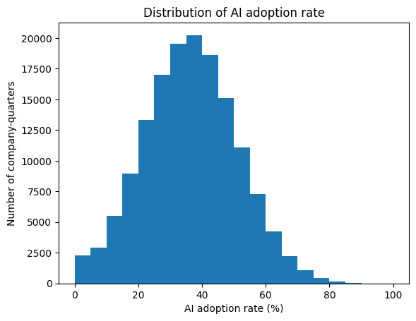
Figure 2. Distribution of AI adoption rate across all company-quarters.
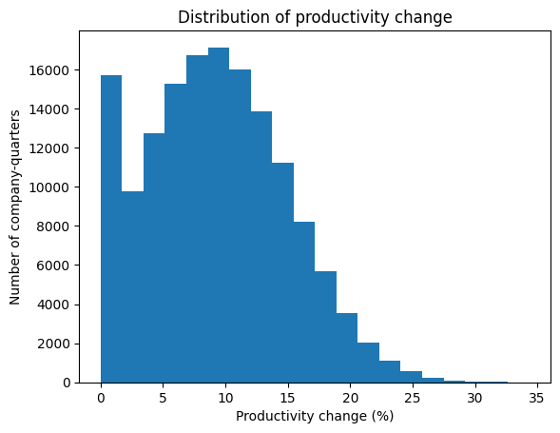
Figure 3. Distribution of productivity change across all company-quarters.
The ai_adoption_rate histogram in Figure 2 is close to symmetric, peaking between 30% and 40%, with very few companies clustered near 0% or above 80%. This shape is consistent with the low skew value reported in Table 2 and suggests that most companies in the dataset sit at a moderate stage of AI adoption rather than at either extreme.
The productivity_change_percent histogram in Figure 3 rises to a peak between 8% and 10% before tailing off to the right toward 30%, matching its positive skew value in Table 2. A smaller secondary rise is visible near 0% to 2% before the main peak, which is flagged here as an unusual pattern worth noting rather than a data-entry error, since it sits within the variable’s valid range; it may represent a distinct subgroup of companies reporting little or no measured productivity gain, separate from the main body of the sample. Neither histogram shows the kind of single isolated bar that the course’s own worked example used to identify a physically impossible value, which supports the data-quality conclusion reached during inspection in Section 4 (AUT, 2026b).

6.3 Outlier Analysis
Figure 4 presents boxplots of both focus variables side by side, following the course’s convention of plotting variables with different scales in separate panels rather than a single shared plot (AUT, 2026b).
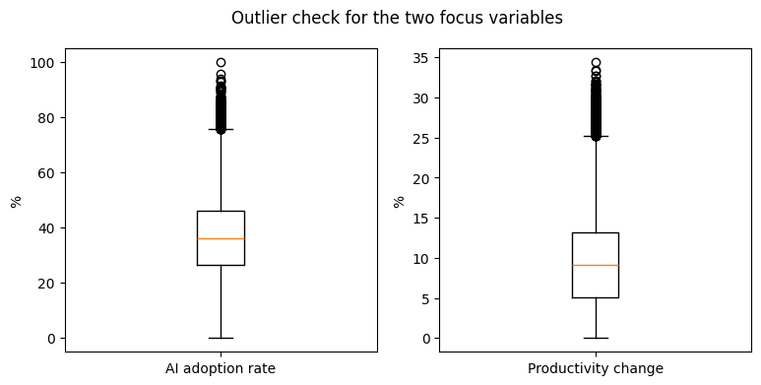
Figure 4. Boxplots of AI adoption rate and productivity change, showing statistical outliers beyond the whiskers.
Both boxplots show a compact middle 50% of values and a one-sided tail of points above the upper whisker, with no flagged points below the lower whisker in either variable. This one-sided pattern is consistent with the mild positive skew already reported for productivity_change_percent and the outlier counts reported in Section 5. Reading the boxplot alongside the interquartile-range outlier counts, rather than relying on the boxplot in isolation, follows the course’s own emphasis that a boxplot identifies statistical rarity rather than proving that a value is incorrect (AUT, 2026b).

6.4 Relationship Analysis
Figure 5 presents a scatter plot of ai_adoption_rate against productivity_change_percent, with a fitted trend line, following the course’s guidance that a scatter plot is the appropriate chart for examining the relationship between two continuous variables (AUT, 2026b).
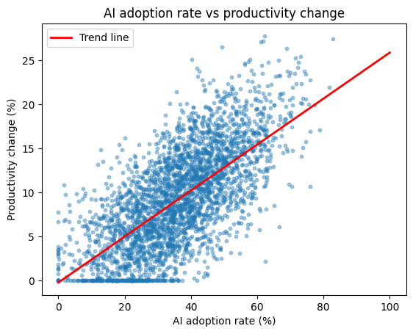
Figure 5. Scatter plot of AI adoption rate against productivity change, with a fitted linear trend line.
The point cloud rises from the bottom-left to the top-right of the plot, and the fitted trend line confirms a positive, roughly linear relationship across the full range of adoption rates. The Pearson correlation coefficient between the two variables was 0.675, as reported in Table 3, indicating a moderately strong positive linear association consistent with the visual pattern in Figure 5.
The spread of points around the trend line indicates that AI adoption rate does not fully determine productivity change on its own, which is expected given that other unmeasured factors, such as industry, company size, or workforce training, are also likely to influence a company’s reported productivity outcome. A horizontal band of points sitting at exactly 0% productivity change is visible across a wide range of adoption rates near the bottom of the plot; this pattern is flagged here as worth further investigation in a later project phase, since it may represent a distinct subgroup of companies rather than a random measurement gap.

6.5 Grouped Comparison
Figure 6 presents mean productivity_change_percent grouped into three AI-adoption bands, Low, Medium, and High, following the course’s demonstration of comparing a single aggregated value across categories with a bar chart (AUT, 2026b).
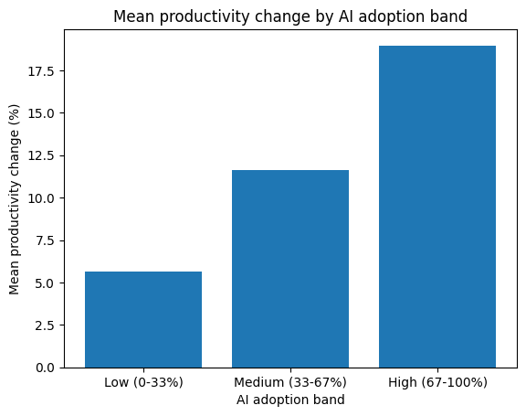
Figure 6. Mean productivity change by AI adoption band (Low, Medium, High).
Mean productivity change increases from 5.62% in the Low band to 11.63% in the Medium band and 18.97% in the High band, showing a step-wise increase across the three bands. This grouped view is a derived summary of the same two focus variables rather than the introduction of a new variable, which keeps the analysis consistent with the single-comparison scope agreed after the lecturer’s Phase 1 feedback. The bar chart necessarily hides the spread of values within each band, so it is read together with the scatter plot in Figure 5 and the boxplots in Figure 4 rather than as evidence on its own.

6.6 Correlation Heatmap and Visualisation Choices
Figure 7 presents a correlation heatmap of the two focus variables, following the course’s demonstration of visualising a correlation matrix with a diverging colour scale (AUT, 2026b).
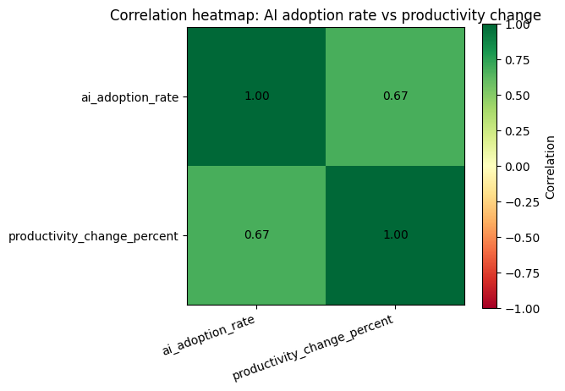
Figure 7. Correlation heatmap of AI adoption rate and productivity change.
The heatmap confirms the Pearson correlation coefficient reported in Table 3, providing a second, visual confirmation of the relationship already identified in the scatter plot.
Two further chart types listed in the Phase 1 task description, the pair plot and the missing-value plot, were considered and deliberately not used for this comparison. A pair plot is most useful for scanning several variable pairs at once, as demonstrated in the course using four ECG measurements together (AUT, 2026b); with only two focus variables in this narrowed project, a pair plot would repeat the histograms in Figures 2 and 3 and the scatter plot in Figure 5 without adding new information. A missing-value plot is most useful when a dataset contains columns with a meaningful proportion of missing data, as demonstrated in the course using the arrhythmia dataset’s largely missing j_angle column (AUT, 2026b); because Section 4 confirmed zero missing values in both focus columns, a missing-value plot for this comparison would show only two bars at zero height and would not add evidence beyond the written confirmation already provided.

7. Limitations and Reflection
This project’s findings are correlational rather than causal, and the course material explicitly cautions against interpreting a strong correlation as proof that one variable causes another (AUT, 2026b); a higher-adoption company might already have been more productive before adopting AI, rather than becoming more productive because of it.
The panel structure of the dataset, in which each of 10,000 companies contributes an unequal number of quarterly responses, means the 150,000 rows are not fully independent observations, and a future project phase could account for this by aggregating to one row per company or using a model that accounts for repeated measures.
The dataset’s four listed survey-source categories, including named organisations such as a McKinsey report and a WEF survey, could not be independently verified against real published surveys within the scope of this project, so they are treated here as descriptive metadata rather than as verified provenance.
Narrowing the project to a single comparison, in direct response to the lecturer’s Phase 1 feedback, produced a clearer and more thoroughly justified analysis than the group’s earlier multi-variable draft, and this trade-off between breadth and depth is one of the clearest lessons the group has taken from Phase 1.

8. Conclusion
This report has documented a data engineering and exploratory data analysis pipeline built around a single, focused research question: how AI adoption rate compares with productivity rate at the company level. The dataset was justified against the Phase 1 selection criteria, inspected and documented for structure and data quality, cleaned and narrowed following direct lecturer feedback, and analysed using the histogram, boxplot, scatter plot, bar chart, and correlation heatmap techniques taught across the course’s lecture material.
Descriptive and visual analysis both indicate a moderately strong positive relationship between AI adoption rate and productivity change, with a Pearson correlation coefficient of 0.675, while also indicating that adoption rate alone does not fully account for the variation in reported productivity outcomes. These findings, together with the limitations documented in Section 7, provide a foundation for a subsequent modelling phase that could test this relationship using the machine learning techniques introduced later in the course.

References
Auckland University of Technology. (2026a). ENGE707: Data engineering and AI — Week 1 theory notes [Unpublished course materials]. School of Engineering, Computer and Mathematical Sciences.
Auckland University of Technology. (2026b). ENGE707: Data engineering and AI — Weeks 2 and 3 combined lecture notes [Unpublished course materials]. School of Engineering, Computer and Mathematical Sciences.
OECD. (2024). The impact of artificial intelligence on productivity, distribution and growth: Key mechanisms, initial evidence and policy challenges (OECD Artificial Intelligence Papers No. 15). OECD Publishing. https://doi.org/10.1787/8d900037-en
OECD/BCG/INSEAD. (2025). The adoption of artificial intelligence in firms: New evidence for policymaking. OECD Publishing. https://doi.org/10.1787/f9ef33c3-en
Thalla, M. K. (2026). Global AI adoption & workforce impact dataset [Data set]. Kaggle. https://www.kaggle.com/datasets/mohankrishnathalla/global-ai-adoption-and-workforce-impact-dataset

